1. Press maintain key on the panel which on the right top, the user =5 ,password= 2222, then press input

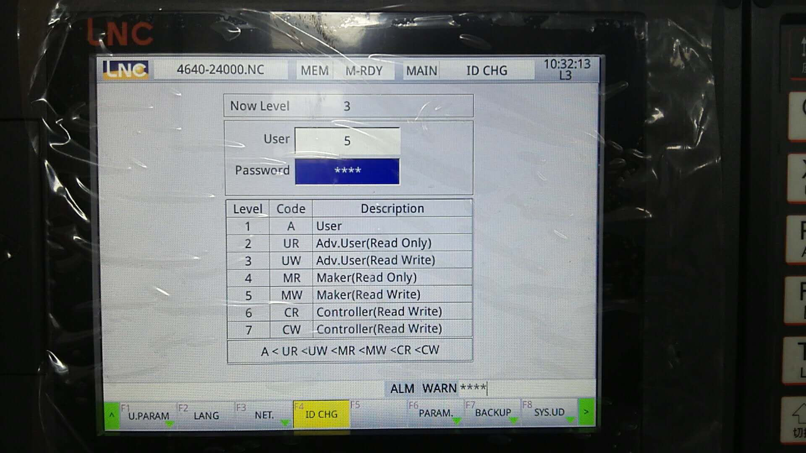

1. Press prog---turn page---F1MAKER MAC, press F2 file MGT, you can see macro list, press IMP\EXP, that’s for macro output or input，choose the one you want to transfer, then press TRFR, then system will complete the transfer.

